Human Fall Detection Using Computer Vision

*Abin Abraham, Neeraj Ghate, Siddharth Apte, Dr.Manisha Dhudediya*

*Marathwada Mitra Mandal’s College of Engineering, Pune*

***Abstract—* The elderly is showing a steady rise in their growth in recent years. Most elderly people who live alone in their own homes don’t usually get any attention or observation. As a result, they are susceptible to falls and are often unconscious in emergencies after the fall. These falls lead to both fatal and non-fatal emergencies. During such falls an alert or immediate medical help can reduce the adversity that comes with the impact. There are some overall limitations with existing methods available to help them. The majority of methods include the use of technologies like wearable sensors and ambient sensors, but they are often invasive inaccessible, and expensive, we have taken into consideration these factors and concluded a solution to the problem of cost and comfort. Here we have designed a system that is a computer vision-based fall detection that accurately classifies fall and non-fall. We were able to achieve an accuracy of 98.5% to 99% using motion history images of the video input received by the camera that is interfaced with the Raspberry Pi. This model will be installed in the room to detect the falls and report them to provide quick medical attention. Furthermore, the results were also recorded for self-made video inputs and some other critical observations have also been highlighted in the paper.**

1. INTRODUCTION

Recently, we are witnessing that elderly people have been forced to live alone due to the effects of a rapidly changing modern-day society. Also, according to recent reports, the old-age dependency ratio is expected to rise from 22% in 2010 to 37% by 2050. Falls have been one of the major health hazards among the population of age over 60 living alone and accidental falls have become a widespread accident among them. It is estimated that 30% of people aged above 65 and 50% of those above 85, fall at least once every year real-time detection of falls can help provide an immediate intervention of medical attendees to ensure a timely treatment resulting in a greater probability of saving lives, reducing medical expenses, and lowering anxiety within the adult. Unfortunately, the existing methods cannot effectively detect falls in complicated. Hence to mitigate the impacts and minimize the consequences caused by falls, researchers have extensively studied various viable solutions and it has been found that older adults living alone are especially prone to delay medical attention during falls. Hence it is necessary to have an automated fall detection and notification system to provide the required assurance and timely help. We propose an automatic, non-obtrusive, Computer vision-based, portable, and cheap fall detection system where fall detection occurs by considering motion history images and velocities is also introduced. The environments, for the falls on furniture, have unique features from falls on the floor because of involving furniture. To automatically detect the human fall in real-time and provide medical rescue timely, it is extremely important to achieve highly accurate fall detection in complicated environments, especially for the falls on furniture which are big challenges for the existing methods. For the reasons described above and other reasons, an increased number of researchers are keen on fall detection and activity classification and have published much literature on this domain.

Keywords—Computer Vision, Convolutional Neural Networks, Classification, Raspberry Pi, Fall Detection

1. Literature Survey

Scott et al. [1] proposed a detection method called bed exit apparatus to recognize the presence of the patient. It is incredibly helpful for caregiver to identify the patient fall and fall pattern. It consists of a sensor located on the surface, and a processor for monitoring and analyzing the signal for detecting a change in the position of the body.

Majd Alwan et al. [2] presented a fall detector based on smart and passive floor vibration-based sensor to overcome the disadvantage of the wearable sensor-based fall detector. This detector is unobtrusive and unreceptive to a person. It uses vibration pattern to detect fall. The operation is tested by using anthropomorphic dummies. Systems using this type of sensor are inexpensive; the performance of these systems is based on the type of floor, having a limited detection range.

Licai Zhu [3] proposed a passive RFID tag-based system called 'Tagcare'. Author monitors changes in the received signal strength and Doppler frequency when regular action and sudden fall occurs. Using wavelet transform and Support Vector Machine (SVM) robust system is designed with a True Positive Rate (TPR) of 99%.

Zhang et al. [4] present unobtrusive ambient fall detection methods based on active and passive sensing systems. These systems can be fitted in the home environment to monitor fall prone areas.

George Vavoulas et al.[5] described a fall classification with a smartphone. It uses a set of Mobifall activity dataset to test detection methods. The dataset contains th signals recorded by the accelerometer and gyroscope sensors of the latest technology smartphone. Four different types of falls and nine different activities of daily life were available in the dataset. This paper presents a comparison of FD based on threshold-based methods and machine learning based methods. The results of an assessment show that FD based on machine learning is a promising solution compared to the threshold-based method.

2.1 VISION BASED

Shehroz S. Khan [6] explores review of FD methods as per the data availability based

selection of classifiers. When sufficient data for simulated fall is available then supervised means are suitable. However, a generalization of these types of methods is difficult due to variation in real fall and simulated fall. Classifiers widely used by various researchers in this category is SVM, One class SVM (OCSVM), and k-NN. When less training dataset is available, then sampling and semi-supervised techniques are most suited. The author also states the open study area in case few fall dataset or no dataset availability. The author suggests that the use of auto-encoders or exploitation of Recurrent Neural Network (RNN) is a good alternative due to the sequential nature of fall event.

Fouzi [7] has stated a real-time FD system using multivariate exponentially weighted

moving average approach for human FD. SVM classifier is used for classification of events from URFD and FDD benchmark datasets. The proposed method is easy to implement on hardware and achieves 97% accuracy using SVM on Fall Detection Dataset (FDD) dataset and 96.66 % results on URFD.

Imen Charfi [3] proposed SVM based FD system. In this method features such as height and width of the bounding box, trajectory information, and orientation are extracted and fed to an SVM classifier. The Le2i dataset is used for evaluation of the method with various combinations of environments available in Le2i

Qian et al. [4] introduced an FD system in a home environment based on a cascaded SVM classifier to differentiate the fall action from other kinds of activities. Appropriate features with its corresponding kernel function achieve good classification performance during training and testing. The experimental result shows the correct identification rate of 98.13% on real activity videos. The system demonstrated its robustness of detection on realistic videos consisting of simulated falls and other daily activities.

Lin et al. [5] fall used human silhouettes to improve privacy protection in the video surveillance system to automatically detect fall incidents. This method is based on the evaluation of posture, based on their angle of inclination and the aspect ratio. This system uses k-NN to classify postures and detect fall using the transition time from a temporary pose to a lying position. Experimental results show that the system effectively distinguishes the fall event and the lying occasion with a correct rate of 86.11%.

Kepski et al. [6] introduced an FD using a 3D ceiling mounted depth camera. Head floor distance, area and shape features are used to train the k-NN classifier. It separates the lying position from everyday activities. For differentiating intentional, accidental falls and extended postures, motion features are being used.

Indoor human FD using CNN is explored by Kripesh [7]. CNN model is evaluated using various combination of Kinect camera input images. The author concludes that background subtraction before training the CNN model is most useful for pose recognition. This method archives an accuracy of 99% for FD.

Rule-based filtered data is fed to optical ow feedback CNN [8]. FD is achieved by frame sequencing. The system produced the correct ratio of 82.7% on benchmark Royal Institute of Technology (KTH) dataset and 98% on the simulated home environment.

In [9] the author presented real-time FD system design based on dataset recorded from Dynamic Vision Sensor and implemented using DNN. The system is designed for a real-time application using embedded hardware and achieved F-1 score of 95.5%.

HFD using R-CNN is explored by Weidong [10]. Human and furniture are detected by R-CNN method. After human detection tracking is done by aspect ratio, centroid, and movement speed, this system is suitable for detection of fall like scene such as sitting or lying down and achieved an accuracy of 95.5%.

Vision-based fall detector system based on transfer learning from action recognition to fall detection is implemented by Adrin Nez-Marcos [11]. The system was tested o URFD, Multicam, and FDD publicly available datasets. This novel approach finds the correlation between the consecutive frames instead of finding the optical ow and stacking them together. It also achieves environmental independence in removing any appearance-based features.

1. TECHNICAL SPECIFICATIONS
2. Convolutional Neural Network Algorithm:

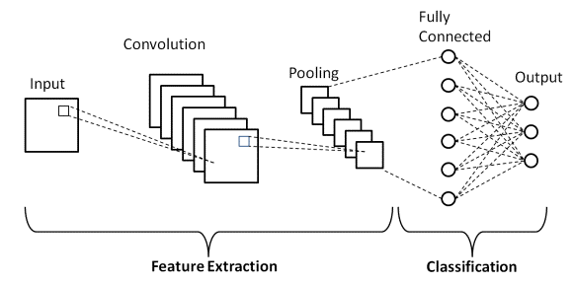

Fig 3.1: Convolutional Neural Network Algorithm Block Diagram

A Convolutional Neural Network (ConvNet/CNN) is a Deep Learning algorithm that can take in an input image, assign importance (learnable weights and biases) to various aspects/objects in the image, and can differentiate one from the other.

The architecture of a ConvNet is analogous to that of the connectivity pattern of Neurons in the Human Brain and was inspired by the organization of the Visual Cortex. Individual neurons respond to stimuli only in a restricted region of the visual field known as the Receptive Field. A collection of such fields overlap to cover the entire visual area.

1. Raspberry Pi:

Fig 3.2: Raspberry Pi Specifications model

The Raspberry Pi is a low-cost, **credit-card-sized computer** that plugs into a computer monitor or TV and uses a standard keyboard and mouse. It is a capable little device that enables people of all ages to explore computing and to learn how to program in languages like Scratch and Python. It’s capable of doing everything you’d expect a desktop computer to do, from browsing the internet and playing high-definition video, to making spreadsheets, word-processing, and playing games.

1. Block Diagram:

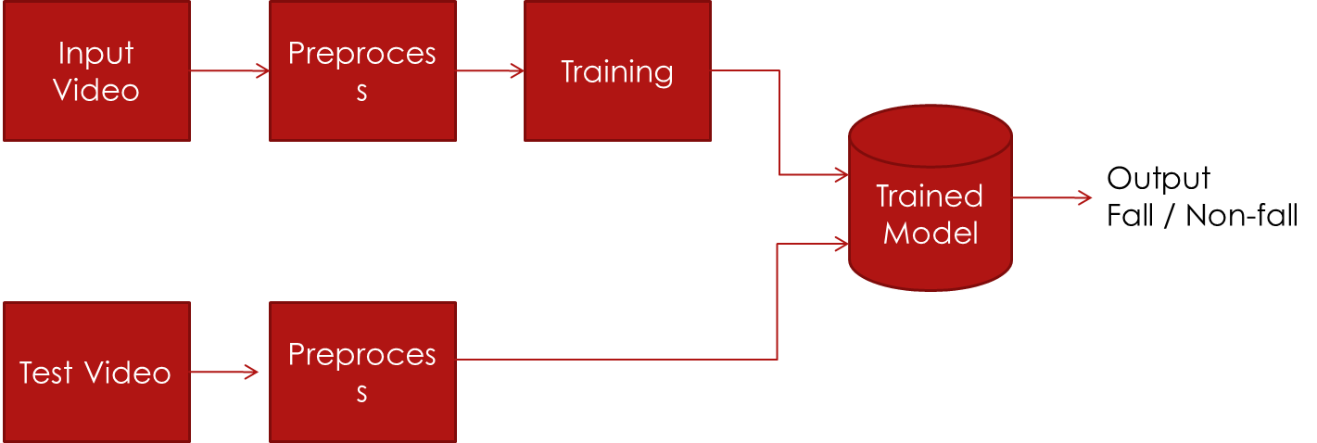

1. Concept of MHI:

MHI stands for Motion History Image. For a standard colored image frame in a video, the bit depth is 24. This means that there are 3 layers of Red (R), Green (G), and Band blue (B) with each layer having an ng bit depth of 8. When this image is converted into MHI format averaging of greyscalescale takes place and the bit depth of the whole image gets reduced to 8. This augmentation leads to faster image processing and substantially improves the model accuracy. Also, MHI can be set to user required intervals and the frame rate can be adjusted, in turn balancing the distribution of frames.

Fig 3.3 a

Fig 3.3 b

**

**Fig 3.3c**

1. Fig 3.4: Circuit Diagram of the System proposed

For the hardware part of the project, we have used the Raspberry pi 3b model. We have connected a camera as shown below in the diagram. The camera will take video input in real-time and will not record the person using it to provide security and privacy. This will solve the issue of storage problems as well and the hardware will be self-sufficient and can be used without the need for a database. Having said that, it may be used with a database as and when required. Thus, we can conclude the issue of portability, privacy, and storage is addressed and justified.

Flowchart—

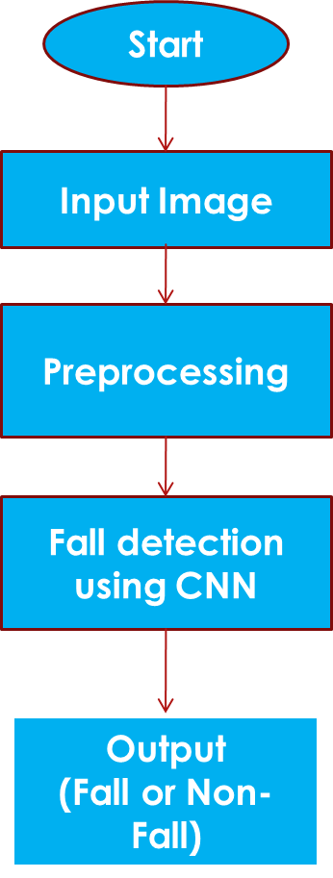

Figures—Based on the model, following the accuracy

and loss comparison to train and test the data.

IV. RESULTS

Model: "sequential":

_________________________________________________________________

Layer (type) Output Shape Param #

=================================================================

conv2d (Conv2D) (None, 223, 223, 256) 3328

activation (Activation) (None, 223, 223, 256) 0

max_pooling2d (MaxPooling2D (None, 111, 111, 256) 0

)

conv2d_1 (Conv2D) (None, 110, 110, 128) 131200

activation_1 (Activation) (None, 110, 110, 128) 0

max_pooling2d_1

(MaxPooling (None, 55, 55, 128) 0 2D)

flatten (Flatten) (None, 387200) 0

dense (Dense) (None, 64) 24780864

activation_2 (Activation) (None, 64) 0

dropout (Dropout) (None, 64) 0

dense_1 (Dense) (None, 2) 130

Total params: 24,915,522

Trainable params: 24,915,522

Non-trainable params: 0

Found 15992 images belonging to 2 classes.

Found 3997 images belonging to 2 classes.

Epoch 1/15

310/310 [==============================] - 1446s 5s/step - loss: 0.2715 - accuracy: 0.9109 - val_loss: 0.0605 - val_accuracy: 0.9854

Epoch 2/15

310/310 [==============================] - 1015s 3s/step - loss: 0.0968 - accuracy: 0.9776 - val_loss: 0.0734 - val_accuracy: 0.9729

Epoch 3/15

310/310 [==============================] - 708s 2s/step - loss: 0.0716 - accuracy: 0.9861 - val_loss: 0.1453 - val_accuracy: 0.9646

Epoch 10/15

310/310 [==============================] - 143s 461ms/step - loss: 0.0347 - accuracy: 0.9964 - val_loss: 0.0263 - val_accuracy: 0.9979

Epoch 15/15

310/310 [==============================] - 132s 427ms/step - loss: 0.0362 - accuracy: 0.9966 - val_loss: 3.8259e-06 - val_accuracy: 1.0000

V. CONCLUSION

We can conclude that the accuracy achieved by our model in classifying human falls ass a non-fall is around 99% as per the graph plotted above.

VI. ACKNOWLEDGMET

The author would like to thank the people who have read the paper and provided the necessinputputs. Special thanks to Project Guides.

VII.REFERENCES

1. O. P. Popoola and K. Wang, “Video-based abnormal human behavior recognitiona review,” *IEEE Transactions on Systems, Man, and Cybernetics, Part C (Applications and Reviews)*, vol. 42, no. 6, pp. 865–878, Nov 2012.
2. A. A. Sodemann, M. P. Ross, and B. J. Borghetti, “A review of anomaly detection in automated surveillance,” *IEEE Transactions on Systems, Man, and Cybernetics, Part C (Applications and Reviews)*, vol. 42, no. 6, pp. 1257–1272, Nov 2012.
3. WHO. (2018) News article. [Online]. Available: [https://www.who.int/fr/](https://www.who.int/fr/news-room/fact-sheets/detail/falls)

[news-room/fact-sheets/detail/falls](https://www.who.int/fr/news-room/fact-sheets/detail/falls)

1. R. J. Gurley, N. Lum, M. Sande, B. Lo, and M. H. Katz, “Persons found in their homes helpless or dead,” *New England Journal of Medicine*, vol. 334, no. 26, pp. 1710–1716, 1996, pMID: 8637517. [Online]. Available: <https://doi.org/10.1056/NEJM199606273342606>
2. J. T. Perry, S. Kellog, S. M. Vaidya, J.-H. Youn, H. Ali, and H. Sharif, “Survey and evaluation of real-time fall detection approaches,” in *2009 6th International Symposium on High Capacity Optical Networks and Enabling Technologies (HONET)*.

IEEE, 2009, pp. 158–164.

1. T. Li, H. Chang, M. Wang, B. Ni, R. Hong, and S. Yan, “Crowded scene analysis: A survey,” *IEEE transactions on circuits and systems for video technology*, vol. 25, no. 3, pp. 367–386, 2015.
2. S. Co¸sar, G. Donatiello, V. Bogorny, C. Garate, L. O. Alvares, and F. Br´emond,

“Toward abnormal trajectory and event detection in video surveillance,” *IEEE*

*Transactions on Circuits and Systems for Video Technology*, vol. 27, no. 3, pp.

683–695, 2017.

1. V. Reddy, C. Sanderson, and B. C. Lovell, “Improved anomaly detection in crowded scenes via cell-based analysis of foreground speed, size and texture,” in *CVPR 2011 WORKSHOPS*. IEEE, 2011, pp. 55–61.
2. R. T. Collins, A. J. Lipton, and T. Kanade, “Introduction to the special section on video surveillance,” *IEEE Transactions on pattern analysis and machine intelligence*, vol. 22, no. 8, pp. 745–746, 2000.
3. P. Boissy, S. Choquette, M. Hamel, and N. Noury, “User-based motion sensing and fuzzy logic for automated fall detection in older adults,” *Telemedicine and e-Health*, vol. 13, no. 6, pp. 683–694, 2007.
4. F. Bagala, C. Becker, A. Cappello, L. Chiari, K. Aminian, J. M. Hausdorff, W. Zijlstra, and J. Klenk, “Evaluation of accelerometer-based fall detection algorithms on real-world falls,” *PloS one*, vol. 7, no. 5, p. e37062, 2012.
5. M. Kangas, A. Konttila, I. Winblad, and T. Jamsa, “Determination of simple thresholds for accelerometry-based parameters for fall detection,” in *2007 29th Annual International Conference of the IEEE Engineering in Medicine and Biology Society*. IEEE, 2007, pp. 1367–1370.
6. K. Chaccour, R. Darazi, A. H. El Hassani, and E. Andr`es, “From fall detection to fall prevention: A generic classification of fall-related systems,” *IEEE Sensors Journal*, vol. 17, no. 3, pp. 812–822, 2017.
7. T. E. Scott, “Bed exit detection apparatus,” May 23 2000, uS Patent 6,067,019.
8. M. Alwan, P. J. Rajendran, S. Kell, D. Mack, S. Dalal, M. Wolfe, and R. Felder, “A smart and passive floor-vibration based fall detector for elderly,” in *Information and Communication Technologies*, vol. 1, no. 2, 2006, pp. 1003–1007.
9. L. Zhu, R. Wang, Z. Wang, and H. Yang, “Tagcare: Using rfids to monitor the status of the elderly living alone,” *IEEE Access*, vol. 5, pp. 11364–11373, 2017.
10. Q. Zhang and M. Karunanithi, “Feasibility of unobstrusive ambient sensors for fall detections in home environment,” in *2016 38th Annual International Conference of the IEEE Engineering in Medicine and Biology Society (EMBC)*. IEEE, 2016, pp.

566–569.

1. G. Vavoulas, M. Pediaditis, C. Chatzaki, E. G. Spanakis, and M. Tsiknakis, “The mobifall dataset: Fall detection and classification with a smartphone,” *International Journal of Monitoring and Surveillance Technologies Research (IJMSTR)*, vol. 2, no. 1, pp. 44–56, 2014.
2. I. Charfi, J. Miteran, J. Dubois, M. Atri, and R. Tourki, “Optimised spatiotemporal descriptors for real-time fall detection: comparison of svm and adaboost based classification,” *Journal of Electronic Imaging (JEI)*, vol. 22, no. 4, p. 17, 2013.
3. E. Auvinet, C. Rougier, J. Meunier, A. St-Arnaud, and J. Rousseau, “Multiple cameras fall dataset,” *DIRO-Universit´e de Montr´eal, Tech. Rep*, vol. 1350, 2010.
4. X. Ma, H. Wang, B. Xue, M. Zhou, B. Ji, and Y. Li, “Depth-based human fall detection via shape features and improved extreme learning machine,” *IEEE journal of biomedical and health informatics*, vol. 18, no. 6, pp. 1915–1922, 2014.
5. B. Kwolek and M. Kepski, “Human fall detection on embedded platform using depth maps and wireless accelerometer,” *Computer methods and programs in biomedicine*, vol. 117, no. 3, pp. 489–501, 2014.
6. M. Blank, L. Gorelick, E. Shechtman, M. Irani, and R. Basri, “Actions as spacetime shapes,” in *null*. IEEE, 2005, pp. 1395–1402.
7. M. Mubashir, L. Shao, and L. Seed, “A survey on fall detection: Principles and approaches,” *Neurocomputing*, vol. 100, pp. 144–152, 2013.
8. E. Akagu¨ndu¨z, M. Aslan, A. S¸engu¨r, H. Wang, and M. C. Ince, “Silhouette orienta-˙ tion volumes for efficient fall detection in depth videos,” *IEEE journal of biomedical and health informatics*, vol. 21, no. 3, pp. 756–763, 2017.
9. S. Albawendi, A. Lotfi, H. Powell, and K. Appiah, “Video based fall detection using features of motion, shape and histogram,” in *Proceedings of the 11th PErvasive*

*Technologies Related to Assistive Environments Conference*. ACM, 2018, pp. 529–

536.

1. J.-L. Chua, Y. C. Chang, and W. K. Lim, “A simple vision-based fall detection technique for indoor video surveillance,” *Signal, Image and Video Processing*, vol. 9, no. 3, pp. 623–633, 2015.
2. R. Cucchiara, A. Prati, and R. Vezzani, “A multi-camera vision system for fall detection and alarm generation,” *Expert Systems*, vol. 24, no. 5, pp. 334–345, 2007.
3. C. Rougier, J. Meunier, A. St-Arnaud, and J. Rousseau, “Fall detection from human shape and motion history using video surveillance,” in *21st International*

*Conference on Advanced Information Networking and Applications Workshops (AINAW’07)*, vol. 2. IEEE, 2007, pp. 875–880.

1. M. Yu, A. Rhuma, S. M. Naqvi, L. Wang, and J. Chambers, “A posture recognitionbased fall detection system for monitoring an elderly person in a smart home environment,” *IEEE transactions on information technology in biomedicine*, vol. 16, no. 6, pp. 1274–1286, 2012.
2. D. N. Olivieri, I. G. Conde, and X. A. V. Sobrino, “Eigenspace-based fall detection and activity recognition from motion templates and machine learning,” *Expert Systems with Applications*, vol. 39, no. 5, pp. 5935–5945, 2012.
3. L. Yang, Y. Ren, H. Hu, and B. Tian, “New fast fall detection method based on spatio-temporal context tracking of head by using depth images,” *Sensors*, vol. 15, no. 9, pp. 23004–23019, 2015.
4. T. Liao and C.-L. Huang, “Slip and fall events detection by analyzing the integrated spatiotemporal energy map,” in *2010 20th International Conference on Pattern Recognition*. IEEE, 2010, pp. 1718–1721.
5. C. Chen, R. Jafari, and N. Kehtarnavaz, “A survey of depth and inertial sensor fusion for human action recognition,” *Multimedia Tools and Applications*, vol. 76, no. 3, pp. 4405–4425, 2017.
6. S. S. Khan and J. Hoey, “Review of fall detection techniques: A data availability perspective,” *Medical engineering & physics*, vol. 39, pp. 12–22, 2017.
7. F. Harrou, N. Zerrouki, Y. Sun, and A. Houacine, “Vision-based fall detection system for improving safety of elderly people,” *IEEE Instrumentation & Measurement Magazine*, vol. 20, no. 6, pp. 49–55, 2017.
8. H. Qian, Y. Mao, W. Xiang, and Z. Wang, “Home environment fall detection system based on a cascaded multi-svm classifier,” in *2008 10th International Conference on Control, Automation, Robotics and Vision*. IEEE, 2008, pp. 1567–1572.
9. B.-S. Lin, J.-S. Su, H. Chen, and C. Y. Jan, “A fall detection system based on human body silhouette,” in *2013 Ninth International Conference on Intelligent Information Hiding and Multimedia Signal Processing*. IEEE, 2013, pp. 49–52.
10. M. Kepski and B. Kwolek, “Fall detection using ceiling-mounted 3d depth camera,” in *2014 International conference on computer vision theory and applications (VISAPP)*, vol. 2. IEEE, 2014, pp. 640–647.
11. K. Adhikari, H. Bouchachia, and H. Nait-Charif, “Activity recognition for indoor fall detection using convolutional neural network,” in *2017 Fifteenth IAPR International Conference on Machine Vision Applications (MVA)*. IEEE, 2017, pp. 81–84.
12. Y.-Z. Hsieh and Y.-L. Jeng, “Development of home intelligent fall detection iot system based on feedback optical flow convolutional neural network,” *IEEE Access*, vol. 6, pp. 6048–6057, 2018.
13. H. Lee, J. Kim, D. Yang, and J.-H. Kim, “Embedded real-time fall detection using deep learning for elderly care,” *arXiv preprint arXiv:1711.11200*, 2017.
14. W. Min, H. Cui, H. Rao, Z. Li, and L. Yao, “Detection of human falls on furniture using scene analysis based on deep learning and activity characteristics,” *IEEE Access*, vol. 6, pp. 9324–9335, 2018.
15. A. Nu´n˜ez-Marcos, G. Azkune, and I. Arganda-Carreras, “Vision-based fall detection with convolutional neural networks,” *Wireless Communications and Mobile*

*Computing*, vol. 2017, 2017.